Year 6 – 7 maths transition work
Tables search 1
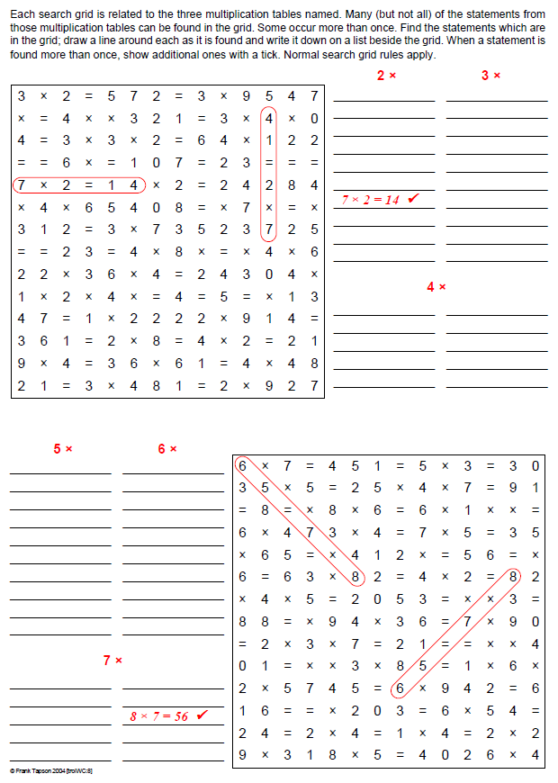

Tables search 2
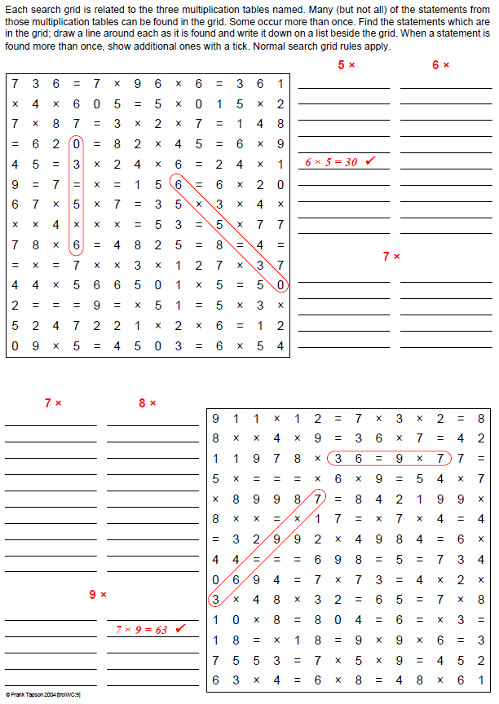

Number patterns 1
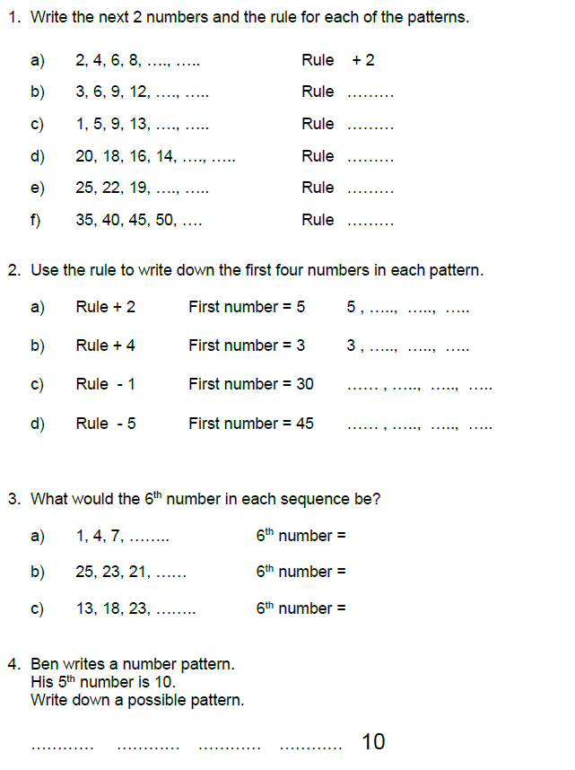

Number patterns 2
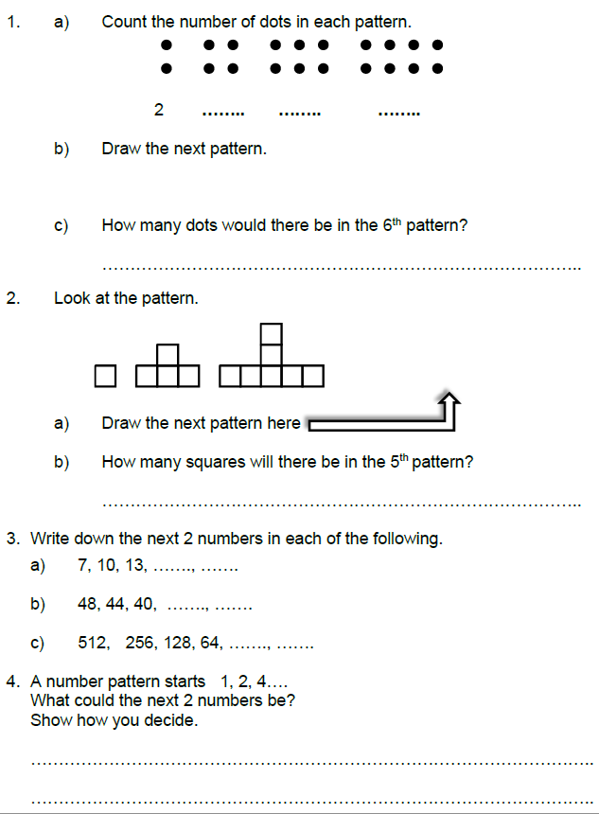

Addition and subtraction
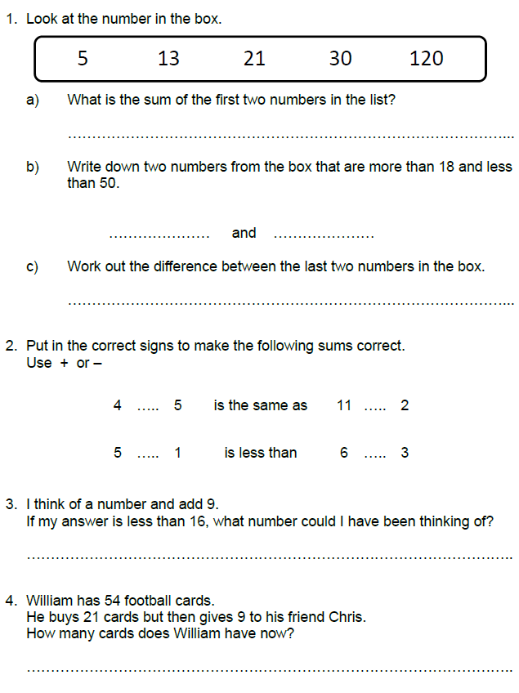

Fractions
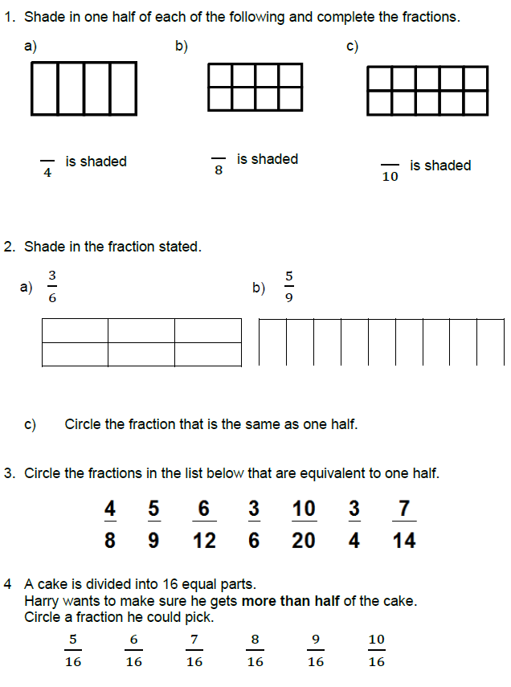

Money and measures
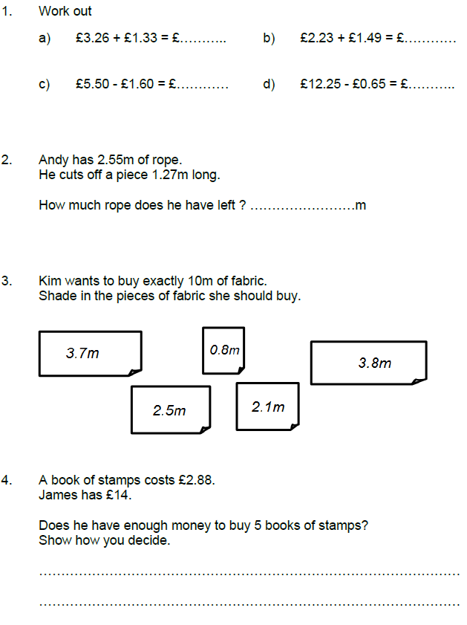

Money problems
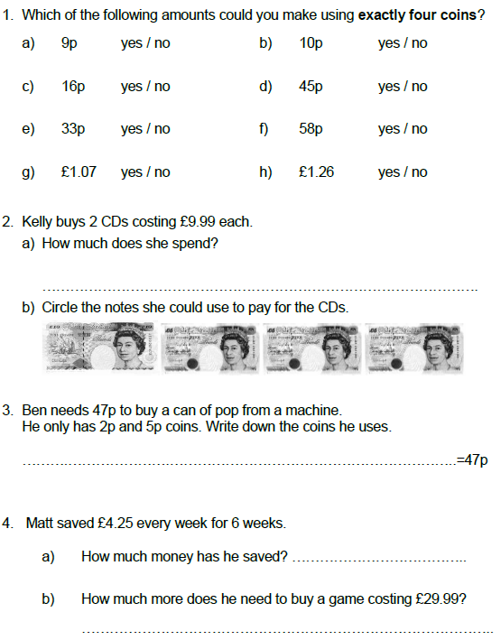

Rectangle areas
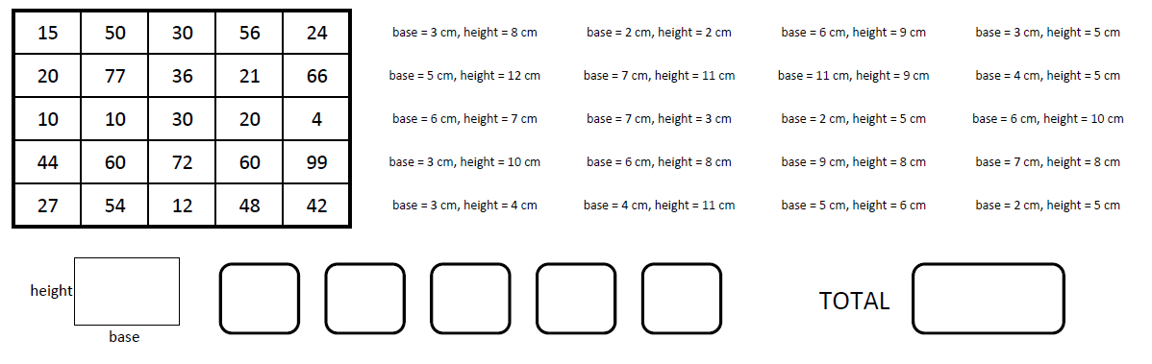
Use the dimensions to work out the area of each of the 20 rectangles. Cross each answer out on the grid on the left as you go. There should be five answers left over. Put these answers in the boxes at the bottom and add them up to get the total.
Numbers in words
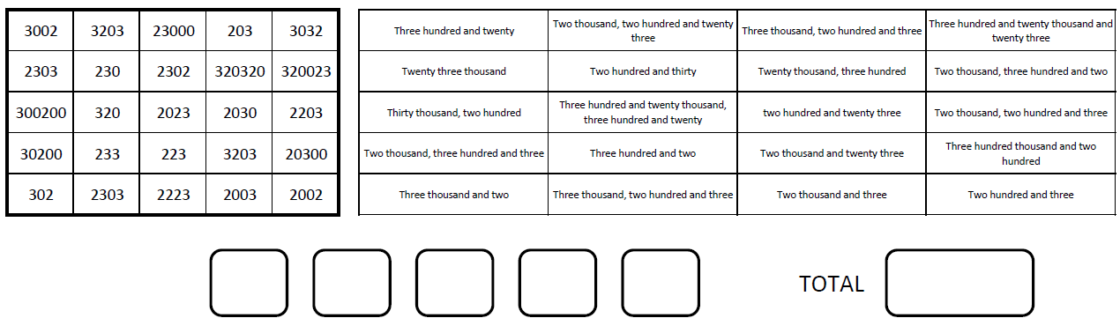
Read the names of the twenty numbers and cross them out as you go. There should be five answers left over. Put these answers in the boxes at the bottom and add them up to get the total.

Addition and subtraction
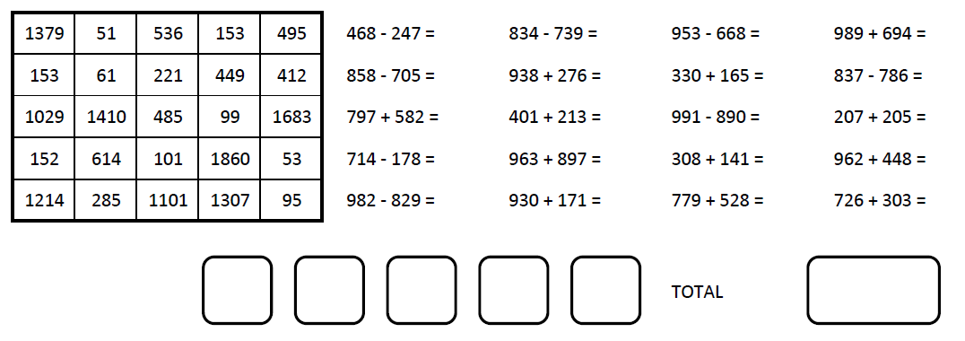
Work out the answers to the 20 questions and cross out the answers in the left hand graid. Put the five left over answers in the boxes and find their total
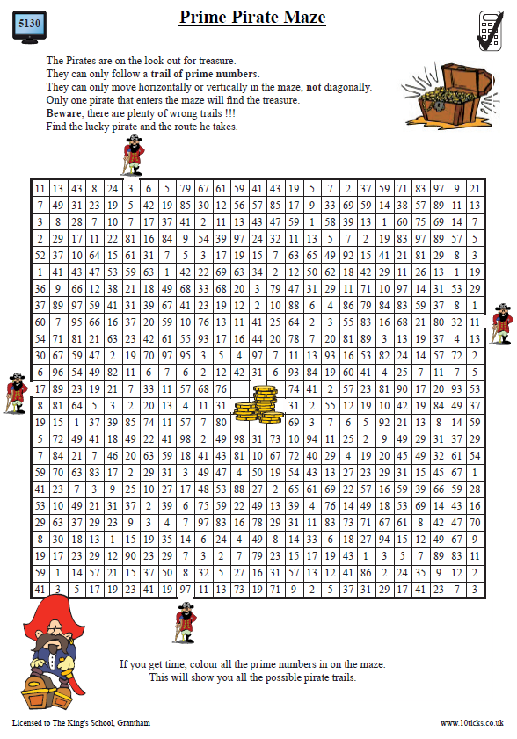

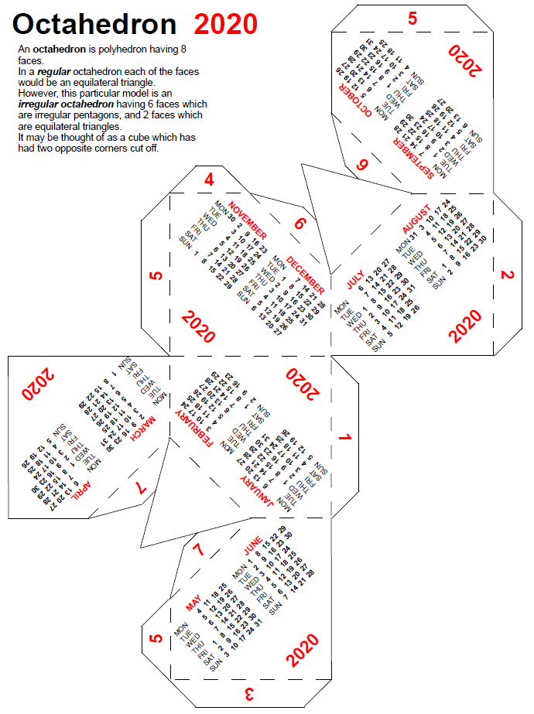

Cut along the solid lines and fold along the dashed lines to make this calendar.

